Selenium WebDriver Architectue Simplified:

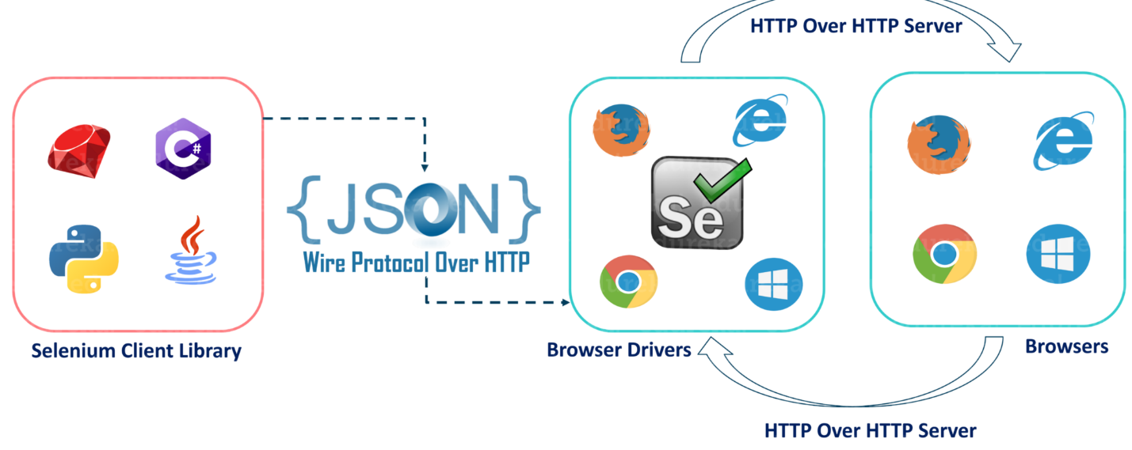

* After you trigger the Test, complete Selenium code (Client) which we have written will be converted to Json format
* Generated Json is sent to Browser Driver (Server) through http Protocol

Note: Each browser contains a separate browser driver

* . Browser drivers communicate with its respective browser and executes the commands by interpreting Json which It received on the browser.
* Browser Driver receives responses back from the browser and it sends Json response back to Client.

import java.time.Duration;

import org.openqa.selenium.By;

import org.openqa.selenium.WebDriver;

import org.openqa.selenium.chrome.ChromeDriver;

public class Locators {

public static void main(String[] args) throws InterruptedException {

// TODO Auto-generated method stub

//implicit wait - 2 seconds time out

System.setProperty("webdriver.chrome.driver", "/Users/rahulshetty/Documents/chromedriver");

WebDriver driver = new ChromeDriver();

driver.manage().timeouts().implicitlyWait(Duration.ofSeconds(5));

driver.get("https://rahulshettyacademy.com/locatorspractice/");

driver.findElement(By.id("inputUsername")).sendKeys("rahul");

driver.findElement(By.name("inputPassword")).sendKeys("hello123");

driver.findElement(By.className("signInBtn")).click();

System.out.println(driver.findElement(By.cssSelector("p.error")).getText());

driver.findElement(By.linkText("Forgot your password?")).click();

Thread.sleep(1000);//

driver.findElement(By.xpath("//input[@placeholder='Name']")).sendKeys("John");

driver.findElement(By.cssSelector("input[placeholder='Email']")).sendKeys("john@rsa.com");

driver.findElement(By.xpath("//input[@type='text'][2]")).clear();

driver.findElement(By.cssSelector("input[type='text']:nth-child(3)")).sendKeys("john@gmail.com");

driver.findElement(By.xpath("//form/input[3]")).sendKeys("9864353253");

driver.findElement(By.cssSelector(".reset-pwd-btn")).click();

System.out.println(driver.findElement(By.cssSelector("form p")).getText());

driver.findElement(By.xpath("//div[@class='forgot-pwd-btn-conainer']/button[1]")).click();

Thread.sleep(1000);

driver.findElement(By.cssSelector("#inputUsername")).sendKeys("rahul");

driver.findElement(By.cssSelector("input[type*='pass']")).sendKeys("rahulshettyacademy");

driver.findElement(By.id("chkboxOne")).click();

driver.findElement(By.xpath("//button[contains(@class,'submit')]")).click();

}

}

**import** org.openqa.selenium.By;

**import** org.openqa.selenium.WebDriver;

**import** org.openqa.selenium.chrome.ChromeDriver;

**public** **class** Locators3 {

**public** **static** **void** main(String[] args) {

// **TODO** Auto-generated method stub

System.setProperty("webdriver.chrome.driver", "/Users/rahulshetty/Documents/chromedriver");

WebDriver driver = **new** ChromeDriver();

// Sibling - Child to parent traverse

//header/div/button[1]/following-sibling::button[1]

driver.get("https://rahulshettyacademy.com/AutomationPractice/");

System.**out**.println(driver.findElement(By.xpath("//header/div/button[1]/following-sibling::button[1]")).getText());

System.**out**.println(driver.findElement(By.xpath("//header/div/button[1]/parent::div/button[2]")).getText());

}

}

*****************************************************************

import org.openqa.selenium.WebDriver;

import org.openqa.selenium.chrome.ChromeDriver;

public class WindowActivities {

public static void main(String[] args) {

// TODO Auto-generated method stub

System.setProperty("webdriver.chrome.driver", "/Users/rahulshetty/Documents/chromedriver");

WebDriver driver = new ChromeDriver();

driver.manage().window().maximize();

driver.get("http://google.com");

driver.navigate().to("https://rahulshettyacademy.com");

driver.navigate().back();

driver.navigate().forward();

}

}